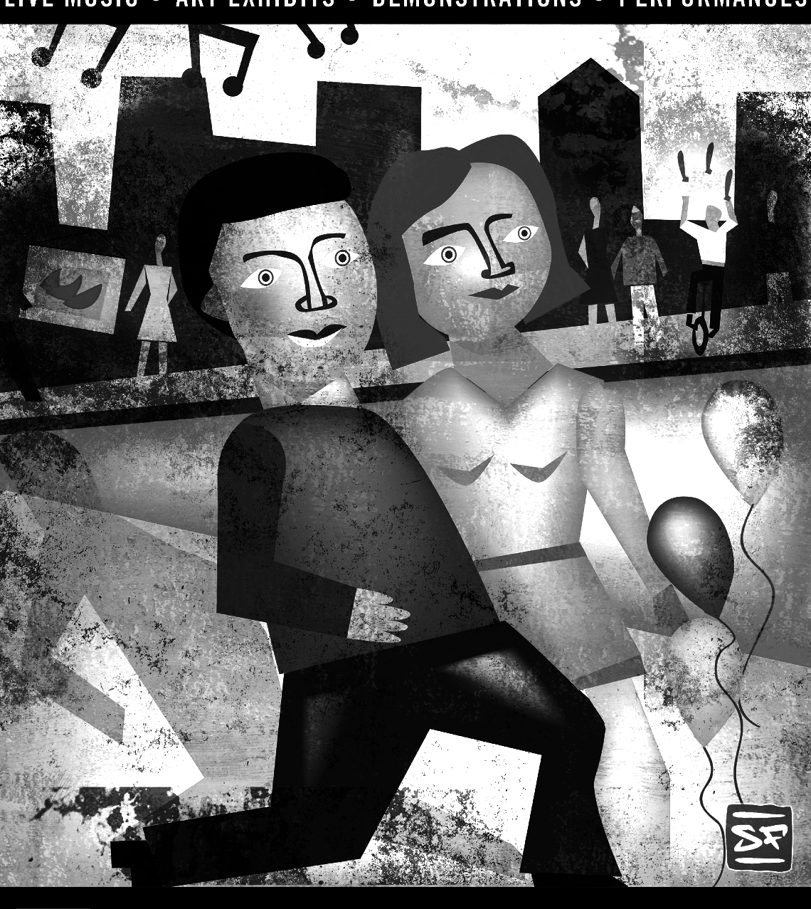
2014 FIRST FRIDAYS
Downtown Putnam, CT
May 2nd, June 6th, July 11th, Aug 1st, Sept 5th, and Oct 3rd

Call for Artists, Food Vendors and
Musical Performers

An Art-based Street Festival will be held on Main Street in Putnam, CT every First Friday of the month from May through October 2014. The events take place outside with all the activities, vendors, a Beer Garden and people right on the street. Putnam is one of the most vibrant small towns in Connecticut, offering some of the best dining experiences, antique shopping and performing arts in the area.

Potential participants can choose from the following 3 categories: Food Vendors, Artist Vendors & Musical Performances. We are now accepting applications in all 3 categories for the 2014 season. If you are interested in demonstrating at one of our events please respond by the 26th of each month. If you would like to be in the 2014 Program booklet please respond before April 5th . The PBA will be distributing more than 3,500 copies beginning in May.

Artist Vendors: Selling their own hand-crafted pieces of art will be given prime locations for 10x10 displays on Main Street. Bring your own display and collect your own money. Drive-up access is provided before and after the show.

Food Vendors: Selling ready-to-eat, individual- sized food and drink are strategically placed at highly visible locations. The committee reserves the right to disallow or limit any food directly conflicting with local Main St. restaurants.

Musical Performances: By one or more musicians, either in a publically accessible location or travelling around and is organized by the Music committee. Committee chair is Terry Paquette, of The Stomping Ground.

Electricity is available but on a very limited bases. You will be charged an extra $5 (for a total of $25 per event) and will need to bring 2- 20ft extension cords and mats to cover the cords.

To approve your application, we will need some information about what you plan to offer, the date(s) you are requesting and your payment. Every effort will be made to meet your needs, but obviously, the sooner we get your reply the better.

Warm Regards,

Rhonda Wishart: Strong Body/Strong Mind Yoga Studio
Co-Chair Vendors for 1st Friday-Putnam Business Association
2014 FIRST FRIDAYS RULES & PROCEDURES
FESTIVAL SCHEDULE
Check-In & Set-Up: 4:00 pm – 5:30 pm. All booths should be ready for early-birds at 5:30
Festival Hours: 6:00 pm – 9:00 pm
Everything must be off the street prior to its re-opening at 10 pm.
*Rain or Shine Event No Refunds for bad weather*

The First Friday’s committee may, at their discretion, limit the number of exhibitors in any one medium, or deny reservations to any vendor not in keeping with the feel of an Art-based Street Festival.
You are responsible for the security of your items at all times. Be considerate of your neighbors. Remove trash in your area when you leave.

ARTIST VENDORS: You will be pre-assigned a 10x10 foot space and should not exceed that area. Electricity is very limited.
No commission is collected on the sale of your works. Sales tax in CT is now 6.35%. You are responsible for collecting and reporting your own sales tax to the State of CT. www.ct.gov/drs.
Exhibitors must provide their own displays. Make your set up simple since this is only a 3-hr show. If you choose to use a tent, you MUST weight the legs of your tent (40 lbs each leg). No tent stakes. Please check the weather forecast and plan accordingly.
The artists or their representative must man the booth and be able to talk about the process, materials and workmanship. All exhibited work must be the original work of the registered artist or crafts person.
Absolutely no distributors, dealers, middlemen, kits,
manufactured items, home parties, or buy/sell.

FOOD VENDORS should make us aware of their space needs, or if they require electricity. Food Vendor Permits must be displayed. Northeast District Department of Health, www.nddh.org, or call 860-774-7350 ext. 15, M-F, 7–4

MUSICAL PERFORMANCES will be assigned specific boundaries and times within which to contain their performances, based on the needs of your performance and the needs and timing of other performances.

WEATHER POLICY
All Vendors and their goods should be prepared to withstand the sun, wind, rain and cold temperatures. This is a rain or shine event. If it rains music will be moved to the Montgomery Ward Building.
If the public would be endangered traveling to our event (hurricane, hail) we will cancel the show completely. Announcements will be made on WINY and we will contact you by email Friday morning. You will have the option of a refund of your fee or using it another month.

MARKETING OPPORTUNITIES

• Links to Vendors on website. If you provide some information we will list more than just
the name of your business on the First Friday Event page on discoverputnam.com.

• Vendors can post what they will bring to the next show on First Friday's Facebook Page. Discover Putnam Facebook page will also feature posts.

• You may request a stack of 10-50 program booklets for your personal distribution efforts. This is a 4-color glossy booklet that we will distribute widely to many locations in our 12-town area and across the borders into RI, MA, and into parts of Hartford.

• Artists who are demonstrating, or food vendors giving samples, may be featured in the Program Booklet. We go to print April 5th Only one artist per month will be featured. If you are interested in this opportunity, please act quickly. You must be accepted prior to that deadline. Only one artist per month will be featured. Last minute requests cannot be granted.

• We will advertise on WINY. If you would like to piggy-back onto one of our ads, please
contact Karen Osbrey at WINY for rates and schedules. You must be accepted prior to that deadline

2014 FIRST FRIDAYS Application Agreement
May 4th , June 6th , July 11th , Aug 1st , Sept 5th , and Oct 3rd

Name: _____________________________ Business Name: ________________________________

Address: ________________________________ City: ______________ State: _____ Zip: ___________

Phone(s) ___________________________________ What are you selling? ________________________

E-mail: __________________________________ Website: ______________________________________

Car Make, Color and License Plate: __________________________________________________________

Date(s) Requested:
May 4th, June 6th , July 11th , Aug 1st , Sept 5th , Oct 4th
Information
Artist Vendor: Send (3) recent close-up photos of current work you will be exhibiting with price ranges. Email pictures to rhondawishart45@gmail.com 860-634-0099
Food Vendor: Enclose a proposed menu for each date you have chosen. We are looking for variety so the show is different each month. Email menu to rhondawishart45@gmail.com
Musical Performance: Terry Paquette. Terry@the-stomping-ground.com 860-234-7205
*Send a self-addressed stamped envelope with enough postage if you
would like us to send your materials back to you.*

Fees for one 10 x 10 booth space, per event:
Regular Registration: $20 Art, $20 Food, Add $5 for elec. (Electricity is very limited)
Late Registration: (received after the 26th of the month): $40 Art, $40 Food, Add $5 for elec.
Vendors most bring 2 2ft extension cords and mats to cover cords.
*Rain or Shine Event – No Refunds are given once you have been accepted.*
Please specify dates desired, and send in one check for total amount.

Checks can be made payable to Putnam Business Association and mailed to:
Strong Body/Strong Mind Yoga Studio 112 Main St #8, Putnam, CT 06260
I hereby release the Town of Putnam, the Putnam Business Association, First Fridays and its members of all responsibility for loss or damage to my personal property.
I understand that failure to comply with all FIRST FRIDAYS Rules and Procedures may result in dismissal from the show without a refund.
I will comply with all laws, regulations and ordinances in effect for Putnam, CT.

Signature:
_______________________________________________________

Printed Name: Date:

